# DHCP and DHCP Relay LAB - CML

Contents

DHCP and DHCP Relay LAB - CML 1

Instructions 1

Topology 2

IP Table 2

Activity 2

Part 1 - Configure R2 2

Part 2 – Configure R1 G0/0 as DHCP Client 4

Part 3 – Configure R1 LAN interface as a DHCP Relay 5

Part 4 – Configure hosts as DHCP Client 5

Other Verifications 6

## Instructions

In this lab R2 will act as the DHCP server for two networks.

1. The Local Area Network connected to R1 G0/1

2. The Point to Point (P2P) network for R1 G0/0 interface

In the initial network the only configuration on the devices are the Host Names so a lot will need to be configured for this to work.

## Topology

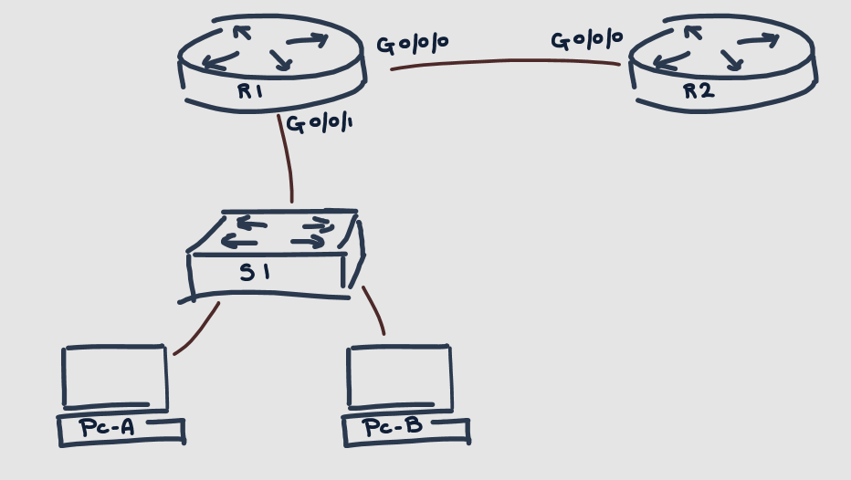

## IP Table

|  |  |  |
| --- | --- | --- |
| **Device** | **Interface** | **Address** |
| **R2** | **G0/0** | **10.1.2.1/24** |
| **R1** | **G0/0** | **DHCP (from P2P pool)** |
| **R1** | **G0/1** | **192.168.0.1/24** |
| **S1** | **VLAN 1** | **DHCP (from MyLAN pool)** |
| **PC-A** | **Eth0** | **DHCP (from MyLAN pool)** |
| **PC-B** | **Eth0** | **DHCP (from MyLAN pool)** |

## Activity

### Part 1 - Configure R2

1. Configure the IP address on **R2 G0/0** as indicated in the IP Table

R2#conf t

R2(config)#int g0/0

R2(config-if)#ip add 10.1.2.1 255.255.255.0

R2(config-if)#no shut

R2(config-if)#exit

R2(config)#

2. Enable the DHCP Service

R2(config)#

R2(config)#service dhcp

R2(config)#

3. Configure the excluded addressed for the P2P network pool. (10.1.2.0/24)

a. Exclude all addresses from

i. **10.1.2.1** up to **10.1.2.252**

ii. The single address **10.1.2.254**

R2(config)#

R2(config)#ip dhcp excluded-address 10.1.2.1 10.1.2.252

R2(config)#ip dhcp excluded-address 10.1.2.254

R2(config)#

* **Note** - This range of excluded addresses is designed to demonstrate how the excluded-address command can work. The goal of this range is to exclude every address except 10.1.2.253 which R1 will be given.

4. Configure the first DHCP pool

a. Called “**P2P**”

b. Only the network command is required (**10.1.2.0/24**)

R2(config)#

R2(config)#ip dhcp pool P2P

R2(dhcp-config)#network 10.1.2.0 255.255.255.0

R2(dhcp-config)#exit

R2(config)#

5. Configure the excluded addresses for the MyLAN network pool.

a. Again we want to customise what addresses can be used. Using only 3 lines can you configure so that addresses

i. **192.168.0.1** up to **192.168.0.100**

ii. **192.168.0.110** up to **192.168.0.252**

iii. **192.168.0.254**

are all excluded.

R2(config)#

R2(config)#ip dhcp excluded-address 192.168.0.1 192.168.0.100

R2(config)#ip dhcp excluded-address 192.168.0.110 192.168.0.252

R2(config)#ip dhcp excluded-address 192.168.0.254

R2(config)#

6. Configure the second DHCP Pool

a. Called “**MyLAN**”

b. The network **192.168.0.0/24**

c. The default gateway of **192.168.0.1**

d. The DNS server **10.2.3.254**

e. The domain name [“**mymindsmadness.co.uk**”](http://mymindsmadness.co.uk)

R2(config)#

R2(config)#ip dhcp pool MyLAN

R2(dhcp-config)#network 192.168.0.0 255.255.255.0

R2(dhcp-config)#default-router 192.168.0.1

R2(dhcp-config)#dns-server 10.2.3.254

R2(dhcp-config)#domain-name mymindsmadness.co.uk

R2(dhcp-config)#exit

R2(config)#

7. Finally, R2 will have no idea how to get to the 192.168.0.0 network once we create it.

a. You can confirm this with the command

*i.* ***Show ip route***

R2#sh ip route

Codes: L - local, C - connected, S - static, R - RIP, M - mobile, B - BGP, D - EIGRP, EX - EIGRP external, O - OSPF, IA - OSPF inter area, N1 - OSPF NSSA external type 1, N2 - OSPF NSSA external type 2, E1 - OSPF external type 1, E2 - OSPF external type 2, E – EGP, i - IS-IS, L1 - IS-IS level-1, L2 - IS-IS level-2, ia - IS-IS inter area, * - candidate default, U - per-user static route, o – ODR, P - periodic downloaded static route

Gateway of last resort is not set

*ii.* ***show ip route 192.168.0.0***

R2#show ip route 192.168.0.0

% Network not in table

b. We will need to ensure that R2 knows how to get the 192.168.0.0/24 network that is connected to R1’s G0/1 interface. To keep this simple let’s use a Static Route informing R2 that to get to the 192.168.0.0/24 network it can simply leave it’s G0/0 interface

R2(config)#

R2(config)#ip route 192.168.0.0 255.255.255.0 g0/0

R2(config)#

### Part 2 – Configure R1 G0/0 as DHCP Client

1. Set up the interface to obtain an **address via DHCP** and ensure it is **activated**.

R1#

R1#conf t

R1(config)#int g0/0

R1(config-if)#ip address dhcp

R1(config-if)#no shut

R1(config-if)#end

R1#

2. You can use the “***Show in interface Brief****”* command to verify that the interface has been given an IP address.

a. This can take time. You should receive output on the CLI indicating that an address has been assigned.

R1#

R1#show ip int brief

Interface IP-Address OK? Method Status Protocol

GigabitEthernet0/0 unassigned YES **DHCP** up up

GigabitEthernet0/1 unassigned YES unset administratively down down

R1#

**\*Jan 5 15:37:05.824: %DHCP-6-ADDRESS_ASSIGN: Interface GigabitEthernet0/0   
assigned DHCP address 10.1.2.253, mask 255.255.255.0, hostname R1**

R1#

R1#show ip int brief

Interface IP-Address OK? Method Status Protocol

GigabitEthernet0/0 **10.1.2.253** YES DHCP up up

GigabitEthernet0/1 unassigned YES unset administratively down down

R1#

### Part 3 – Configure R1 LAN interface as a DHCP Relay

1. This G0/1 interface will need to have an **IP address statically assigned**. Use the address in the IP Table and ensure the interface is **activated**

R1#

R1#conf t

R1(config)#int g0/1

R1(config-if)#ip address 192.168.0.1 255.255.255.0

R1(config-if)#no shut

R1(config-if)#

2. Configure the **IP Helper** command to point to the IP address on R2 **10.1.2.1**

R1(config-if)#

R1(config-if)#ip helper-address 10.1.2.1

R1(config-if)#end

R1#

### Part 4 – Configure hosts as DHCP Client

1. The Desktop PCs in CML are currently set as DHCP clients. This can be verified with the command ***ifconfig***

2. This is not exactly common place but why the F not, lets set the switches SVI address for interface VLAN 1 to be obtained automatically.

a. Configure interface VLAN 1 to obtain an **address via DHCP**

S1#

S1#conf t

S1(config)#int vlan 1

S1(config-if)#ip address dhcp

S1(config-if)#no shut

S1(config-if)#end

S1#

b. Like before this can be verified with the **show ip int brief** command

S1#

S1#show ip int brief

Interface IP-Address OK? Method Status Protocol

---[output omitted]---

**Vlan1 unassigned YES DHCP up up**

S1#

3. This presents a small problem... No matter how long you wait, your switch will not pick up an address.

This is because the DHCP server is on a different (remote) network. In order for a switch to communicate directly with a remote network it requires a default gateway.

a. Configure the Default Gateway as **192.168.0.1**

S1#conf t

S1(config)#

S1(config)#ip default-gateway 192.168.0.1

S1(config)#end

S1#

**\*Jan 5 15:47:36.463: %DHCP-6-ADDRESS_ASSIGN: Interface Vlan1 assigned DHCP address 192.168.0.103, mask 255.255.255.0, hostname S1**

S1#

S1#show ip int brief

Interface IP-Address OK? Method Status Protocol

---[output omitted]---

Vlan1 192.168.0.103 YES DHCP up up

S1#

### Other Verifications

When configuring DHCP you may wish to verify a few things; What you have configured, what addresses are leased to who, any conflicts of addresses. This section will cover the verification

#### Overall DHCP configuration

Viewing your running configuration is always an easy way to reconfirm the commands you have entered. Let's use a pipe and view the DHCP section of the config.

R2#

R2#**show running-config | section dhcp**

ip dhcp excluded-address 10.1.2.1 10.1.2.252

ip dhcp excluded-address 10.1.2.254

ip dhcp excluded-address 192.168.0.1 192.168.0.100

ip dhcp excluded-address 192.168.0.110 192.168.0.252

ip dhcp excluded-address 192.168.0.254

ip dhcp pool P2P

network 10.1.2.0 255.255.255.0

ip dhcp pool MyLAN

network 192.168.0.0 255.255.255.0

default-router 192.168.0.1

dns-server 10.2.3.254

domain-name mymindsmadness.co.uk

R2#

Although viewing the running config is one of the best tools in troubleshooting cisco IOS. Cisco like to make sure you know a few other outputs too. So a great substitute command here is the **show ip dhcp pool** command, which on its own will show you every pool or you can specify which pool you want to see. for example **show ip dhcp pool MyLAN**

R2#

R2#show ip dhcp pool MyLAN

Pool MyLAN :

Utilization mark (high/low) : 100 / 0

Subnet size (first/next) : 0 / 0

Total addresses : 254

Leased addresses : 3

Excluded addresses : 5

Pending event : none

1 subnet is currently in the pool

Current index IP address range Leased/Excluded/Total

192.168.0.1 192.168.0- 192.168.0.254 3 / 5 / 254

R2#

#### Bindings

To see DHCP bindings use the **show ip dhcp bindings** command. This will inform you of the assigned IP address and the MAC address of the device/interface it is assigned to. In bold you can see the R1 G0/0 information

R2#show ip dhcp binding

IP address Client-ID/ Lease expiration Type

Hardware address

**10.1.2.253 0003.E4BB.9701 -- Automatic**

192.168.0.103 0060.3E63.C96C -- Automatic

192.168.0.102 00E0.A3E3.7507 -- Automatic

192.168.0.104 000C.CFB8.A285 -- Automatic

R2#